**Lab Assignment-3**

Name: Khushi Prasad

SubGroup: 3CO20

Roll No.: 102183044

Subject: Data Science Fundamentals

Q1. Create an array A with elements (12, 13, 14, 15, 16) and display them.

CODE:



OUTPUT:



Q2. Find the sum of all the elements of A.

CODE:



OUTPUT:



Q3. Find the product of all the element of A.

CODE:



OUTPUT:



Q4. Find the maximum and minimum element of A.

CODE:



OUTPUT:

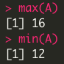

Q5. Find the range of array A.

CODE:



OUTPUT:



Q6. Find the mean, variance, standard deviation and median of value of A.

CODE:

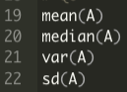

OUTPUT:

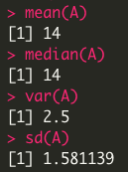

Q7. Sort the element of A both in increasing and decreasing order and store them in B and C.

CODE:

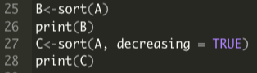

OUTPUT:

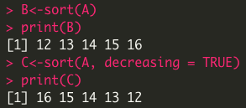

Q8. Create a matrix of 3x4 to have the set of natural numbers.

CODE:



OUTPUT:

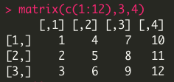

Q9. Create MxN matrix by combining A, B and C row-wise (RW) and column-wise(CW).

CODE:

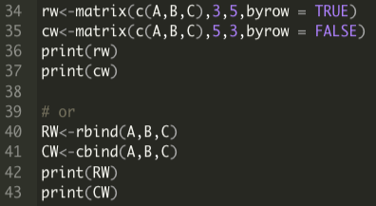

OUTPUT:

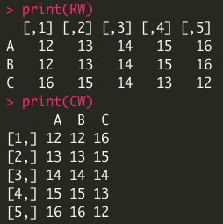

Q10. Find the 2 and 3 row element of RW.

CODE:



OUTPUT:

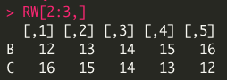

Q11. Find the 1 and 3 column of CW.

CODE:



OUTPUT:

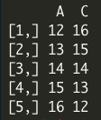

Q12. Using both RW and CW find sub-matrices having elements [2, 3] and [2, 3].

CODE:



OUTPUT:

